**Capstone Project: Youth Smoking**

**Introduction:   
The Capstone Project is a semester long, critical thinking project utilizing a single, large data set. You will be examining this data from the point of view of the concepts in each chapter of the statistics course. The goal is to give you experience in manipulating and analyzing data and to help you understand how decisions are made and conclusions are reached using data.**

**Intermediate assessments will have deadlines scattered throughout the semester. The assignments range from answering questions and making graphs to running hypothesis tests and drawing conclusions regarding the meaning of the data set. For all written responses you are expected to use proper English grammar and to write in complete sentences and, where needed, paragraphs. Statistical graphs should be properly labeled and in a format large and clear enough to be easily understood.**

**About the Dataset**

**In 1979 and 1983, two of the earliest studies in the US were conducted to determine the relationship between children’s lung (pulmonary) function and the absence or presence of cigarette smoke, whether passively or actively inhaled.**

**In particular, researchers from these two studies measured the forced expiratory volume of children aged 3-19. Forced expiratory volume measures how much air (in liters) a person can exhale during a forced breath. The amount of air exhaled can be measured during the first (FEV1), second (FEV2), and/or third seconds (FEV3) of forced breath. The data collected during these studies in the 80s examined FEV1 (hereafter referred to as simply FEV).**

**To perform pulmonary function tests such as FEV, the patient is asked to take the deepest breath they can, and then exhale into the sensor as hard as possible, for as long as possible, preferably at least 6 seconds. Sometimes, the test will be preceded by a period of quiet breathing in and out from the sensor (tidal volume).**

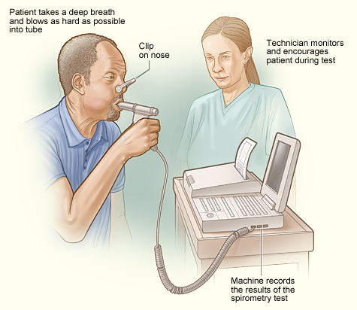

**The maneuver is highly dependent on patient cooperation and effort, and is normally repeated at least three times to ensure quality of results. Due to the effort required, pulmonary function tests can only be used on children old enough to comprehend and follow the instructions given. Other types of lung function tests are available for infants and unconscious persons.**

**Average values for FEV in healthy people depend on varying factors, as we will examine during the capstone. Values of between 80% and 120% of the average value are considered a normal range.**

**Preliminary Discussion Questions**

**In your assigned groups, designate one person to serve as the recorder. Going through each of the questions, and making sure all group members have an opportunity to speak, collectively discuss your thoughts and opinions. The recorder should type, in clear and complete sentences, the results of the group discussion in a Word document. Print this out and turn in before proceeding to the next section.**

1. **What conjectures (educated guesses) could be made about the relationship between smoking and FEV?**
2. **What is the difference between “average” and “normal range”?**
3. **Why is FEV a good variable to measure the effects of smoking on lung function?**